**REG NO. : 412422205009**

**NAME : AKASH RAJ L**

**SOURCE CODE :**

**parking.xml**

<?xml version="1.0" encoding="UTF-8"?>

<?xml-stylesheet type="text/xsl" href="parking.xsl"?>

<parkingSystem xmlns:xsi="http://www.w3.org/2001/XMLSchema-instance"

xsi:noNamespaceSchemaLocation="parking.xsd">

<parkingLot>

<lotID>AB101</lotID>

<lotName>Main Street Lot</lotName>

<capacity>200</capacity>

<occupied>120</occupied>

<available>80</available>

<location>Main Street, Downtown</location>

<ratePerHour>2.00</ratePerHour>

<securityLevel>High</securityLevel>

<type>Public</type>

<operationalHours>24/7</operationalHours>

<contactNumber>1234567890</contactNumber>

</parkingLot>

<parkingLot>

<lotID>CD202</lotID>

<lotName>Park Avenue Lot</lotName>

<capacity>300</capacity>

<occupied>150</occupied>

<available>150</available>

<location>Park Avenue, Uptown</location>

<ratePerHour>1.50</ratePerHour>

<securityLevel>Medium</securityLevel>

<type>Private</type>

<operationalHours>6:00 - 22:00</operationalHours>

<contactNumber>0987654321</contactNumber>

</parkingLot>

<parkingLot>

<lotID>EF303</lotID>

<lotName>Sunset Boulevard Lot</lotName>

<capacity>250</capacity>

<occupied>100</occupied>

<available>150</available>

<location>Sunset Boulevard, West End</location>

<ratePerHour>3.00</ratePerHour>

<securityLevel>High</securityLevel>

<type>Public</type>

<operationalHours>24/7</operationalHours>

<contactNumber>1122334455</contactNumber>

</parkingLot>

<parkingLot>

<lotID>GH404</lotID>

<lotName>Ocean Drive Lot</lotName>

<capacity>400</capacity>

<occupied>350</occupied>

<available>50</available>

<location>Ocean Drive, Coastal Area</location>

<ratePerHour>2.50</ratePerHour>

<securityLevel>Low</securityLevel>

<type>Private</type>

<operationalHours>7:00 - 23:00</operationalHours>

<contactNumber>6677889900</contactNumber>

</parkingLot>

<parkingLot>

<lotID>IJ505</lotID>

<lotName>Central Park Lot</lotName>

<capacity>150</capacity>

<occupied>80</occupied>

<available>70</available>

<location>Central Park, Midtown</location>

<ratePerHour>2.75</ratePerHour>

<securityLevel>Medium</securityLevel>

<type>Public</type>

<operationalHours>5:00 - 22:00</operationalHours>

<contactNumber>9988776655</contactNumber>

</parkingLot>

<parkingLot>

<lotID>KL606</lotID>

<lotName>Elm Street Lot</lotName>

<capacity>180</capacity>

<occupied>130</occupied>

<available>50</available>

<location>Elm Street, Suburbia</location>

<ratePerHour>1.80</ratePerHour>

<securityLevel>High</securityLevel>

<type>Private</type>

<operationalHours>6:00 - 20:00</operationalHours>

<contactNumber>4455667788</contactNumber>

</parkingLot>

<parkingLot>

<lotID>MN707</lotID>

<lotName>Highway 45 Lot</lotName>

<capacity>350</capacity>

<occupied>300</occupied>

<available>50</available>

<location>Highway 45, Outskirts</location>

<ratePerHour>1.50</ratePerHour>

<securityLevel>Low</securityLevel>

<type>Public</type>

<operationalHours>24/7</operationalHours>

<contactNumber>3344556677</contactNumber>

</parkingLot>

<parkingLot>

<lotID>OP808</lotID>

<lotName>Maple Grove Lot</lotName>

<capacity>100</capacity>

<occupied>60</occupied>

<available>40</available>

<location>Maple Grove, Suburbia</location>

<ratePerHour>2.20</ratePerHour>

<securityLevel>High</securityLevel>

<type>Public</type>

<operationalHours>6:00 - 22:00</operationalHours>

<contactNumber>5566778899</contactNumber>

</parkingLot>

<parkingLot>

<lotID>QR909</lotID>

<lotName>Riverside Lot</lotName>

<capacity>120</capacity>

<occupied>100</occupied>

<available>20</available>

<location>Riverside Drive, Downtown</location>

<ratePerHour>2.50</ratePerHour>

<securityLevel>Medium</securityLevel>

<type>Private</type>

<operationalHours>8:00 - 22:00</operationalHours>

<contactNumber>7788990011</contactNumber>

</parkingLot>

</parkingSystem>

**parking.xsd**

<xs:schema xmlns:xs="http://www.w3.org/2001/XMLSchema">

<xs:element name="parkingSystem">

<xs:complexType>

<xs:sequence>

<xs:element name="parkingLot" maxOccurs="unbounded">

<xs:complexType>

<xs:sequence>

<!-- Restriction: Exactly 5 characters, two uppercase letters followed by three digits -->

<xs:element name="lotID">

<xs:simpleType>

<xs:restriction base="xs:string">

<xs:pattern value="[A-Z]{2}[0-9]{3}"/>

<xs:length value="5"/>

</xs:restriction>

</xs:simpleType>

</xs:element>

<!-- Restriction: Lot name must be between 5 and 50 characters -->

<xs:element name="lotName">

<xs:simpleType>

<xs:restriction base="xs:string">

<xs:minLength value="5"/>

<xs:maxLength value="50"/>

</xs:restriction>

</xs:simpleType>

</xs:element>

<!-- Restriction: Capacity between 10 and 1000 -->

<xs:element name="capacity">

<xs:simpleType>

<xs:restriction base="xs:int">

<xs:minInclusive value="10"/>

<xs:maxInclusive value="1000"/>

</xs:restriction>

</xs:simpleType>

</xs:element>

<!-- Restriction: Occupied spaces must be between 0 and the capacity -->

<xs:element name="occupied">

<xs:simpleType>

<xs:restriction base="xs:int">

<xs:minInclusive value="0"/>

<xs:maxInclusive value="1000"/>

</xs:restriction>

</xs:simpleType>

</xs:element>

<!-- Restriction: Available spaces calculated as capacity minus occupied -->

<xs:element name="available">

<xs:simpleType>

<xs:restriction base="xs:int">

<xs:minInclusive value="0"/>

<xs:maxInclusive value="1000"/>

</xs:restriction>

</xs:simpleType>

</xs:element>

<!-- Restriction: Location must be between 5 and 100 characters -->

<xs:element name="location">

<xs:simpleType>

<xs:restriction base="xs:string">

<xs:minLength value="5"/>

<xs:maxLength value="100"/>

</xs:restriction>

</xs:simpleType>

</xs:element>

<!-- Restriction: Rate per hour between 0.50 and 10.00 -->

<xs:element name="ratePerHour">

<xs:simpleType>

<xs:restriction base="xs:decimal">

<xs:minInclusive value="0.50"/>

<xs:maxInclusive value="10.00"/>

<xs:fractionDigits value="2"/>

</xs:restriction>

</xs:simpleType>

</xs:element>

<!-- Restriction: Security level can only be Low, Medium, or High -->

<xs:element name="securityLevel">

<xs:simpleType>

<xs:restriction base="xs:string">

<xs:enumeration value="Low"/>

<xs:enumeration value="Medium"/>

<xs:enumeration value="High"/>

</xs:restriction>

</xs:simpleType>

</xs:element>

<!-- Restriction: Type can only be Public or Private -->

<xs:element name="type">

<xs:simpleType>

<xs:restriction base="xs:string">

<xs:enumeration value="Public"/>

<xs:enumeration value="Private"/>

</xs:restriction>

</xs:simpleType>

</xs:element>

<!-- Restriction: Operational hours must follow the pattern 24/7 or 'HH:MM - HH:MM' -->

<xs:element name="operationalHours">

<xs:simpleType>

<xs:restriction base="xs:string">

<xs:pattern value="24/7|([0-9]{1,2}:[0-9]{2})\s?-\s?([0-9]{1,2}:[0-9]{2})"/>

</xs:restriction>

</xs:simpleType>

</xs:element>

<!-- Restriction: Contact number must be exactly 10 digits -->

<xs:element name="contactNumber">

<xs:simpleType>

<xs:restriction base="xs:string">

<xs:pattern value="\d{10}"/>

</xs:restriction>

</xs:simpleType>

</xs:element>

</xs:sequence>

</xs:complexType>

</xs:element>

</xs:sequence>

</xs:complexType>

</xs:element>

</xs:schema>

**parking.xsl**

<?xml version="1.0" encoding="UTF-8"?>

<xsl:stylesheet version="1.0" xmlns:xsl="http://www.w3.org/1999/XSL/Transform">

<xsl:template match="/">

<html>

<head>

<title>Parking Management System</title>

<style>

table {

width: 100%;

border-collapse: collapse;

}

table, th, td {

border: 1px solid black;

}

th, td {

padding: 8px;

text-align: left;

}

th {

background-color: #f2f2f2;

}

</style>

</head>

<body>

<h2>Parking Management System</h2>

<table>

<tr>

<th>Lot ID</th>

<th>Lot Name</th>

<th>Capacity</th>

<th>Occupied</th>

<th>Available</th>

<th>Location</th>

<th>Rate/Hour</th>

<th>Security Level</th>

<th>Type</th>

<th>Operational Hours</th>

<th>Contact Number</th>

</tr>

<xsl:for-each select="parkingSystem/parkingLot">

<xsl:if test="normalize-space(securityLevel) = 'Medium' and normalize-space(type) = 'Private'">

<tr>

<td><xsl:value-of select="lotID"/></td>

<td><xsl:value-of select="lotName"/></td>

<td><xsl:value-of select="capacity"/></td>

<td><xsl:value-of select="occupied"/></td>

<td><xsl:value-of select="available"/></td>

<td><xsl:value-of select="location"/></td>

<td><xsl:value-of select="ratePerHour"/></td>

<td><xsl:value-of select="securityLevel"/></td>

<td><xsl:value-of select="type"/></td>

<td><xsl:value-of select="operationalHours"/></td>

<td><xsl:value-of select="contactNumber"/></td>

</tr>

</xsl:if>

</xsl:for-each>

</table>

</body>

</html>

</xsl:template>

</xsl:stylesheet>

**OUTPUT :**

1. **IotID**



1. **IotName**



1. **Capacity**



1. **Occupied**



1. **Available**



1. **Location**



1. **ratePerHour**



1. **securityLevel**



1. **Type**



1. **operationalHours**



1. **contactNumber**



**WITH NO ERRORS :**

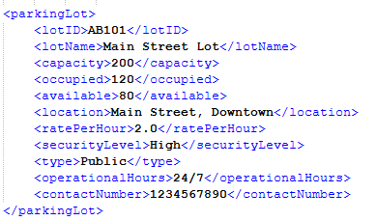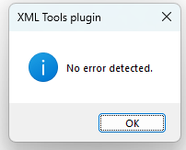

**XSLT :**

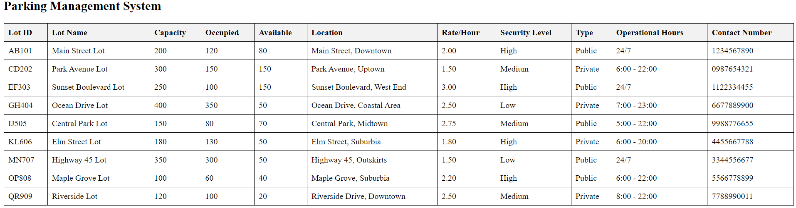

**XSLT SELECTION WITH CONSTRAINTS (securityLevel=”Medium” and type=”Private”):**

